Shad Riley

Enhancement Three Narrative

CS 499

This project was substantially more difficult than the previous two. For my third enhancement, I elected to create an application utilizing the MongoDB database. This application uses PyQt5 to create a graphical user interface (GUI) where users can manipulate data in the MongoDB database.

The create option provides the user with multiple text blocks to enter data for each document. This database follows a schema (See Figure1 below). To create a document, each key such as Animal ID needs to be entered by the user, except DateTime and MonthYear. Those values are created using the built-in python datetime method.

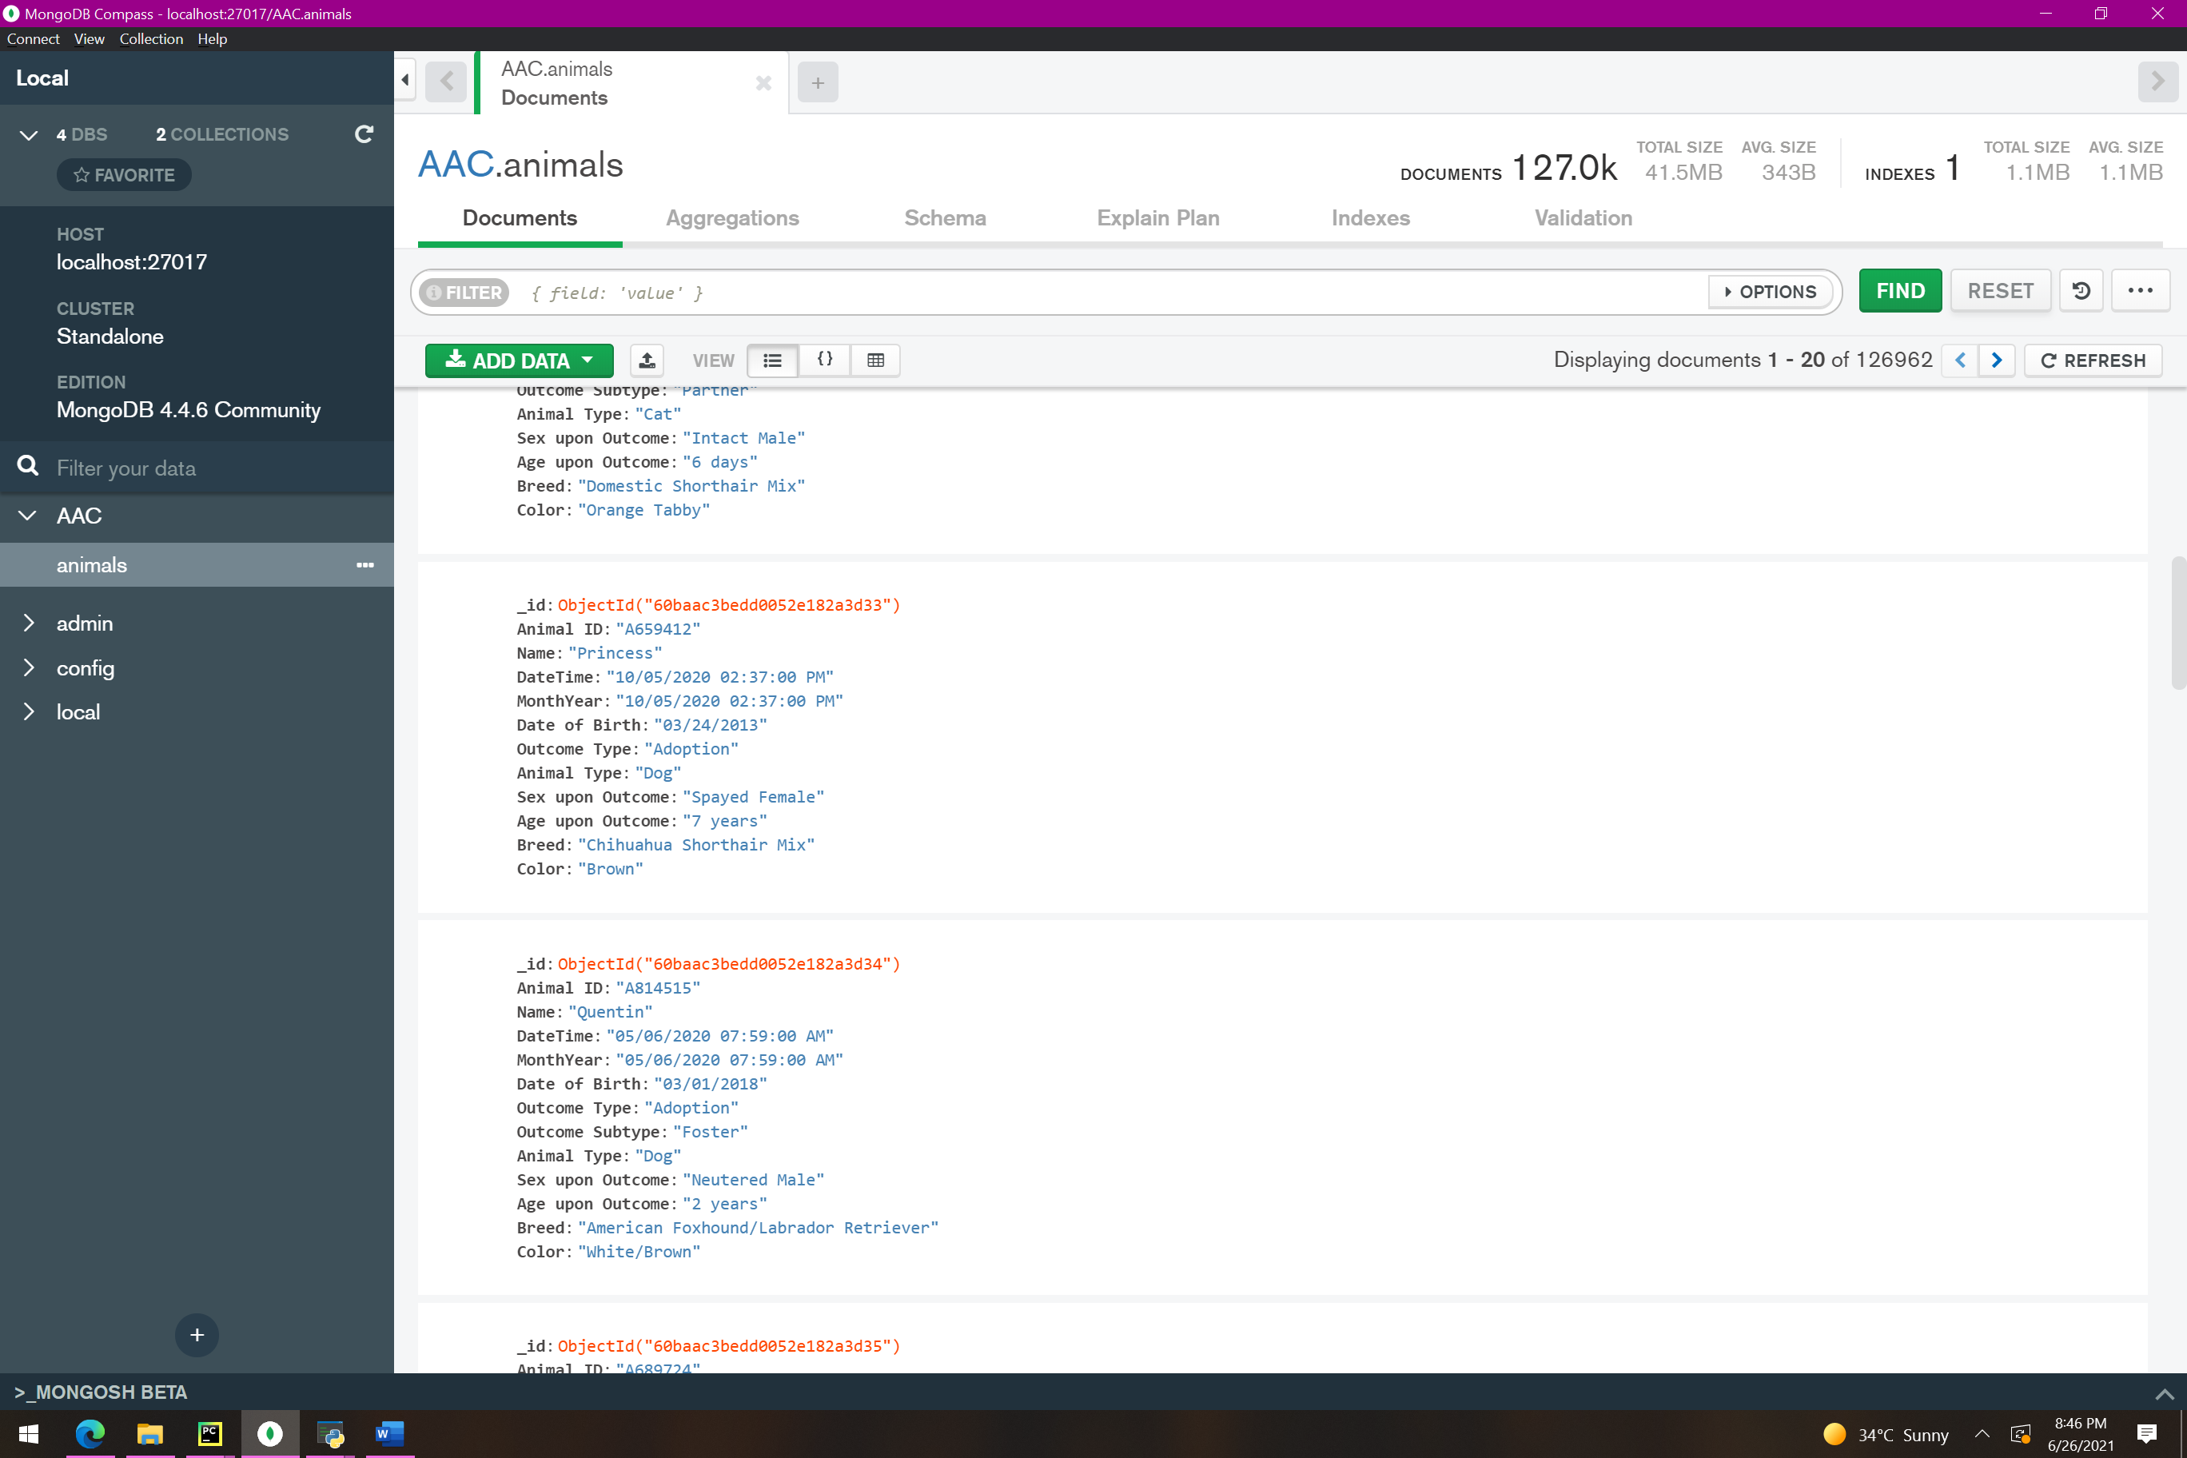

Figure : MongoDB document

The process of enhancing this project here involved using the previously created python functions. Functions had to be modified slightly to accommodate the PyQt GUI interface, such as removing some printed strings from the functions. The text blocks in the create method are particularly useful compared to the command line interface program I created in module one. This allows the user to simply enter the information in one chunk, and data can easily be fixed. If the user sees a typo before creating the final document, they can simply change the text in the box versus starting over completely.

